SDV602 Assignment 2

Ollie Moss

Contents

Introduction 1

Requirements 1

Functional 1

Non-functional 1

Story Boards 1

Test Scripts 1

Coding Practices 1

# Introduction

The proposed application is to provide a way to analyse, view and discuss data sets in a scientific and technical context. To achieve this the application will be separated into 3 Data Explorer Screens (DES). A DES will consist of a graph to visualize the data source, various settings surrounding the data will be provided to manipulate the graph in a purely cosmetically way e.g. pan, zoom, columns, title, etc. Each DES will also provide a text chat in which the current viewers of the DES will be able to communicate through. The final application will be provided with a login and signup functionality.

# Requirements

## Functional

* The system will display 3 data explorer screens
* The system will allow users to login
* The system will allow users to signup
* The system will allow communication between users via the chat system
* The system will display a graph based on the selected dataset
* The system will allow navigation between data explorer screens
* The system will allow all 3 data explorer screens to be viewed at the same time using command line arguments

## Non-functional

* The system will use a weather data of Nelson ranging from 1/1/2023-13/10/2024
* The system will provide a good user experience
* The system will follow good coding practices and formatting
* The system will contain useful comments describing each section’s purpose
* The system will be made in a modular manner, allowing for scalability

# Story Boards

The story boards provided will describe the full functionality of the application including the flow between screens, and the full functionality of each screen.

**Data Explorer Screen:**

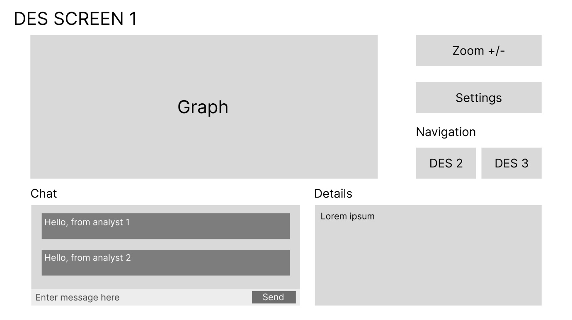

The data explorer screen is where the majority of the time spent while using the application. This screen allows navigation to the other data explorer screens, provides the chat system, and extra details surrounding the dataset selected. This also allows for navigation to the settings menu where the graph can be manipulated. A user will use the chat to discuss the graph with other users and then modify the settings by pressing the settings button, then eventually they may navigate to another data explorer screen in which they will repeat the process until they eventually would like to exit the application using the window exit button.

**Settings Screen:**

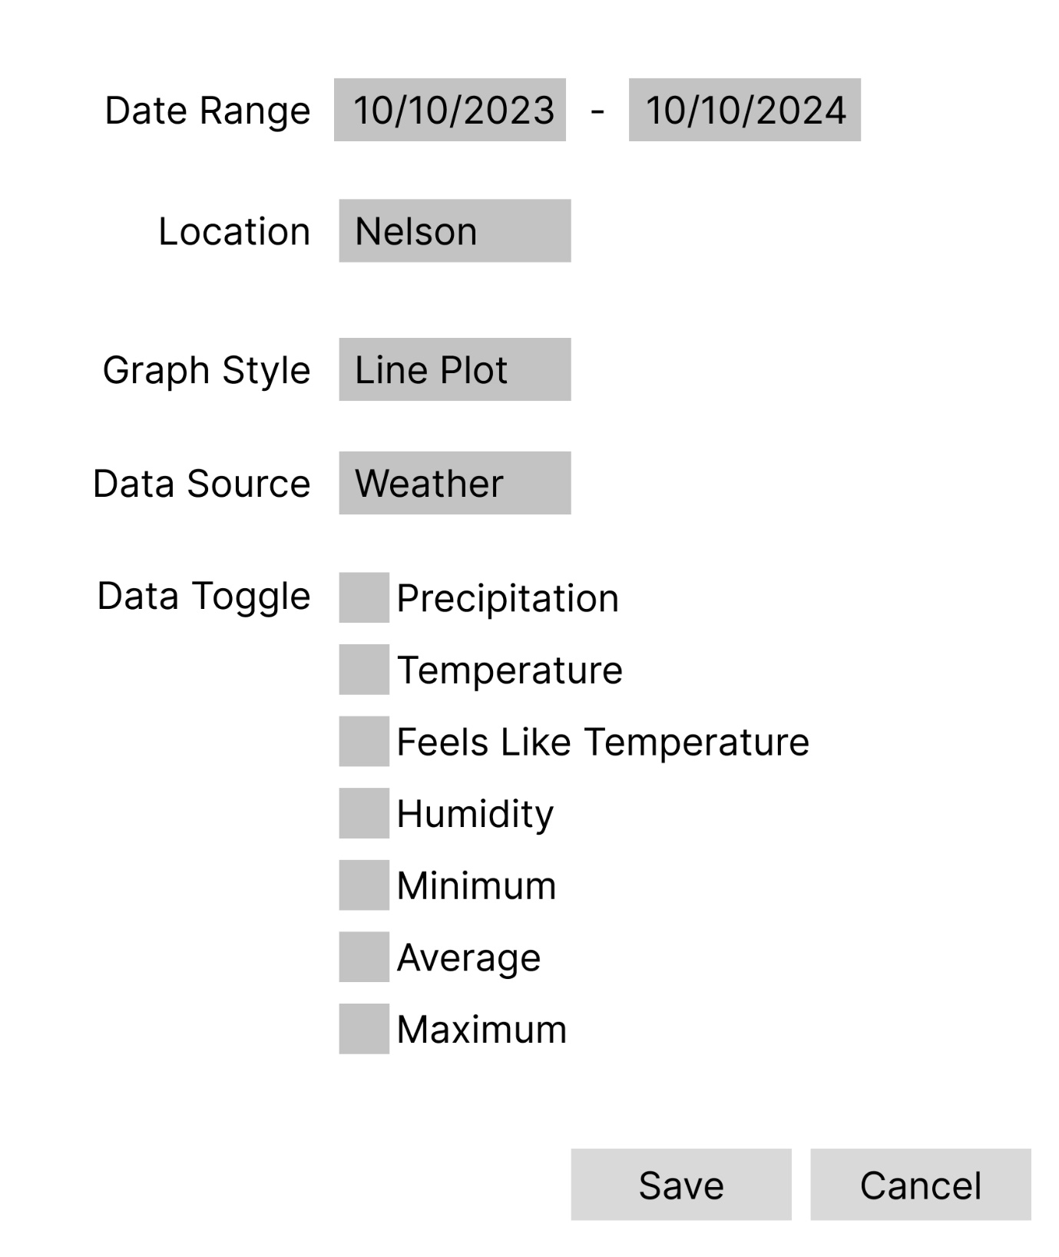

The settings screen allows for manipulation of the graph on a data explorer screen. Users will modify the existing settings to match their desired outcome, if they believe they are happy with the changes they have made they will press save otherwise they will press cancel.

**Login Screen:**

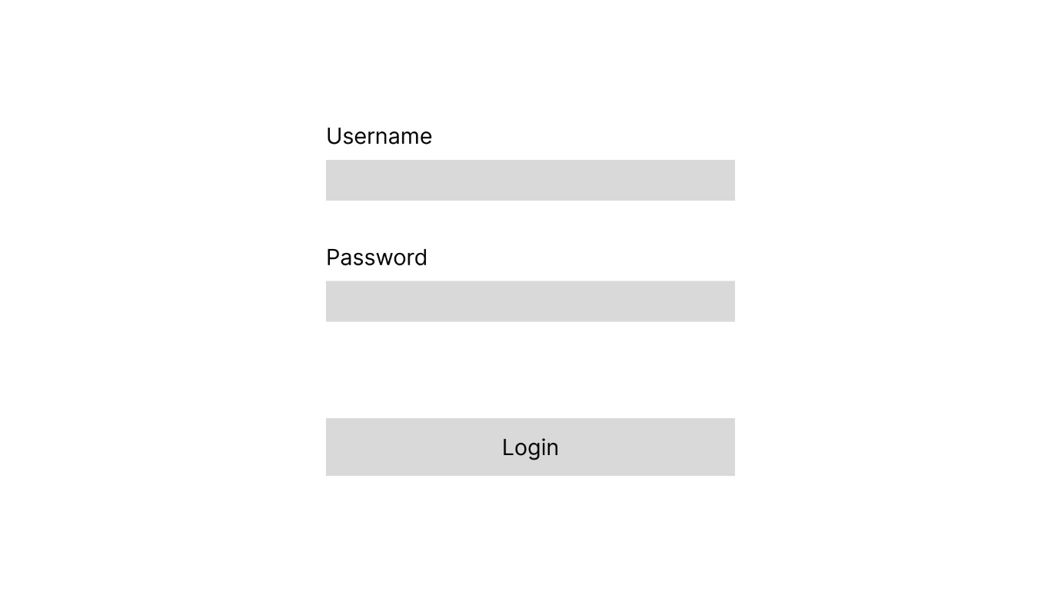

The login screen allows for users to login with existing login credentials. Users will enter their details and press the login button. If the login credentials are valid then the user will be logged in and forwarded to a data explorer screen, otherwise the user will be prompted to enter valid login credentials.

**Register Screen:**

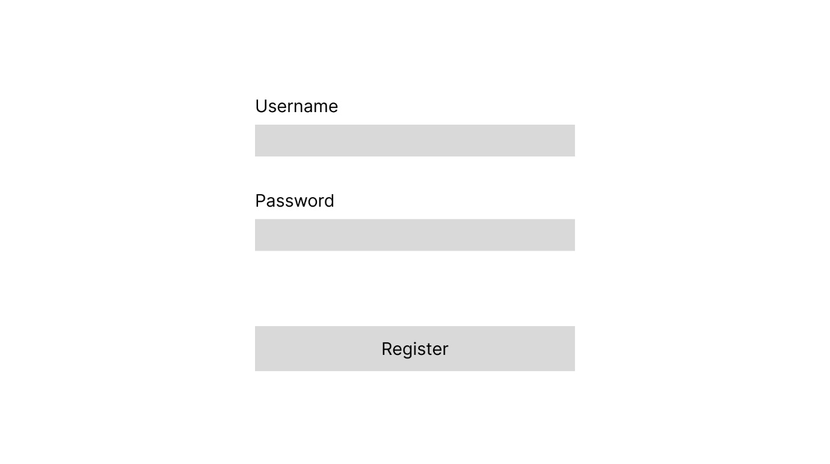

The register screen allows for users to signup, this allows them to make use of the login screen. Users will enter their details and press register, if the username is not already in use an account will be created otherwise the user will be prompted to choose a new username.

# Test Scripts

The provided tests scripts will run the three required DESs, the proposed functionality of the test script is as follows:

* Accept correct input and displays correct information
* Display placeholder for the graph
* Provide navigation to other DES screens, this includes a top-level command interface.

Functionality not provided in the test script is a command line argument for multiple windows at the same time.

# Coding Practices

Comments will follow the pep8 style guide

Code formatting will follow the pep8 style guide

Naming conventions will be clear and also follow the pep8 style guide